Exercises for “Infield” area (while off from your cardio jog)

Choose your partner and then determine who is Captain and who is Coach:
Captain= Selects order of the exercises during each round while in the center.
Coach= Counts the exercises & helps with corrections while in the center.

Round 1=
- 15 crunches (using the fitness gram form of knees bent, feet flat on the floor, hands to side touching the floor and slide them forward as you lift your body ½ way up, hold 1 second and back down)
- 10 push-ups (regular, modified, or plank hold for 30 second count)
- If time remains: seated stretches of your choice (10 counts each, examples: hurdle stretch, sit and reach, hollywoods, shoulder stretches, tricep stretches, repeat)

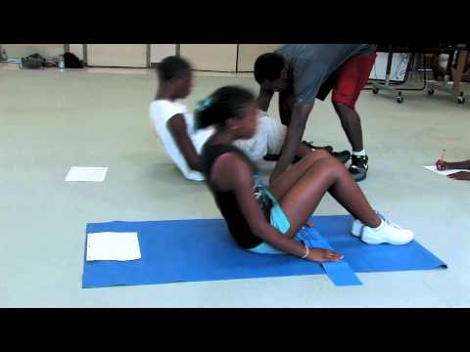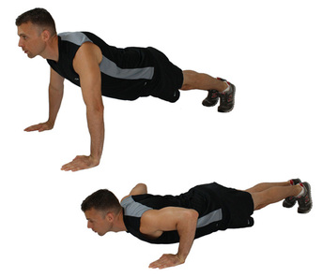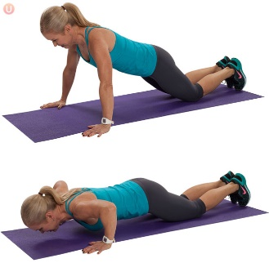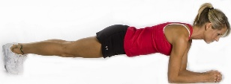

Round 2=
- 5 Burpees (Begin in a standing position, then follow the cue of: down, out, in, up)
- 20 jumping jacks (proper form of arms all the way up and legs apart)
- If time remains: seated stretches of your choice (10 counts each, examples: hurdle stretch, sit and reach, hollywoods, shoulder stretches, tricep stretches, repeat)
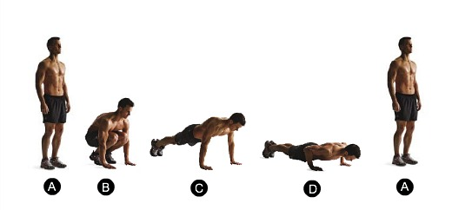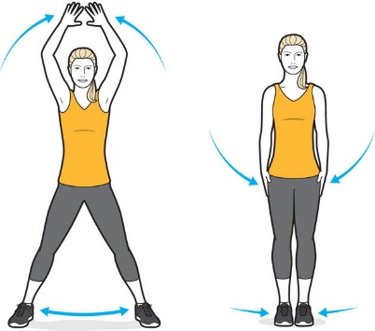

Round 3=
- Arm wrestle your partner using your right arm. (Lay on belly, elbow on the ground)
- Arm wrestle your partner using your left arm. (Lay on belly, elbow on the ground)
- If time remains: seated stretches of your choice (10 counts each, examples: hurdle stretch, sit and reach, hollywoods, shoulder stretches, tricep stretches, repeat)

Round 4=
- 5 Superman holds. (Lay on belly, then lift arms and legs off the ground and hold for 2 to 5 seconds each)
- 5 Air Squats. (As you squat your knees are bent, weight is back on the heels of your feet, and toes are pointed slightly outward. Keep your chest up and shoulders back as if you are trying to squeeze your shoulder blades together. Pretend you are going to sit in a chair)
- If time remains: seated stretches of your choice
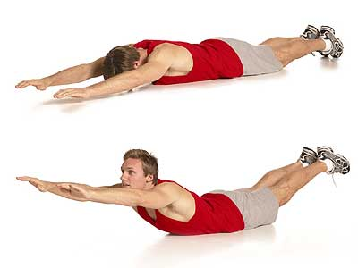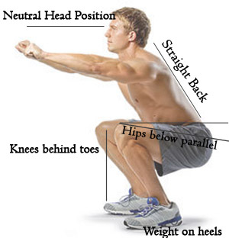

Round 5=
- Repeat Round 1

Round 6 =
- Repeat Round 2

Round 7=
- Repeat Round 3

Round 8 =
- Repeat Round 4

***Study/Quiz your partner on the following terms/concepts:
The 5 Components of Health Related Fitness are:
- Cardiorespiratory Endurance (jogging, cycling, swimming)
- Muscular Strength (lifting a heavy amount of weight one or two times/short amount of repetitions.)
- Muscular Endurance (lifting a light amount of weight for many repetitions, performing an exercise over a prolonged time, such as 80 crunches/situps)
- Flexibility (performing stretches, hurdle stretch, sit and reach, etc)
- Body Composition (percentage of fat, muscle, water and bone found in the human body)
______________________________________________________________________________
What is Aerobic Fitness= Oxygen is the primary source of energy.
- Great exercises for Aerobic Fitness are: jogging, running, swimming, and cycling.
- Aerobic fitness is your ability to take oxygen from the atmosphere and use it to produce energy for your muscle cells.
- The amount of oxygen in the blood, pumped by the heart, and transported to the working muscles, as well as the muscles efficiency in using that oxygen (muscles ability to use that oxygen).

What is Anaerobic Fitness= Sugar is the primary source of energy.

- Anaerobic fitness activities last for a short duration of time. They are high intensity exercises lasting anywhere from a few seconds up to around two minutes. After two minutes, the body's aerobic system kicks in.
- Great exercises for Anaerobic Fitness are: resistance training such as pushups, pull-ups, air squats, lunges, jumping, sprinting a short distance.
_______________________________________________________________________
F.I.T.T. Principle
F=Frequency =How often you exercise
I=Intensity=How hard you are working while exercising
T=Time=How long you exercise
T=Type=What kind of exercise you
Example: Jordan jogs or swims (type of exercise), for 30 minutes (time/how long she exercises) 3 to 5 days a week (frequency of exercise), at a heart rate zone of 140 beats or more per minute (intensity of exercise).

