[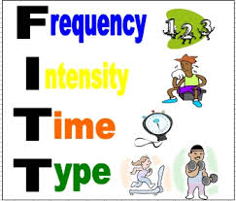](http://www.google.com/url?sa=i&rct=j&q=&esrc=s&source=images&cd=&cad=rja&uact=8&ved=0ahUKEwiezdu55sLKAhXnkoMKHThLDAQQjRwIBw&url=http://david-bracho.com/f-t-t-principles/&psig=AFQjCNHqa7gB7evrM5-M3lId55STd3VFtw&ust=1453736990724448)

[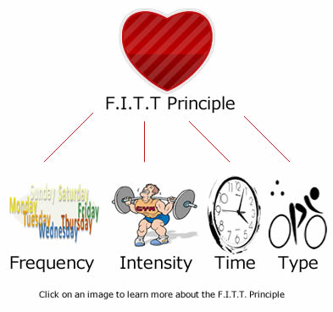](http://www.google.com/url?sa=i&rct=j&q=&esrc=s&source=images&cd=&cad=rja&uact=8&ved=0ahUKEwi3nvTc5sLKAhXEloMKHZQYDu4QjRwIBw&url=http://www.elitemyotherapy.com.au/blog/get-fit-with-the-fitt-principle&psig=AFQjCNHqa7gB7evrM5-M3lId55STd3VFtw&ust=1453736990724448)

[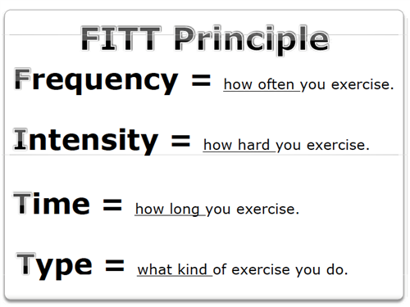](http://www.google.com/url?sa=i&rct=j&q=&esrc=s&source=images&cd=&cad=rja&uact=8&ved=0ahUKEwiU6s6D58LKAhWBkYMKHY1VDksQjRwIBw&url=http://wwwnew.nsd.org/Page/24703&psig=AFQjCNHqa7gB7evrM5-M3lId55STd3VFtw&ust=1453736990724448)[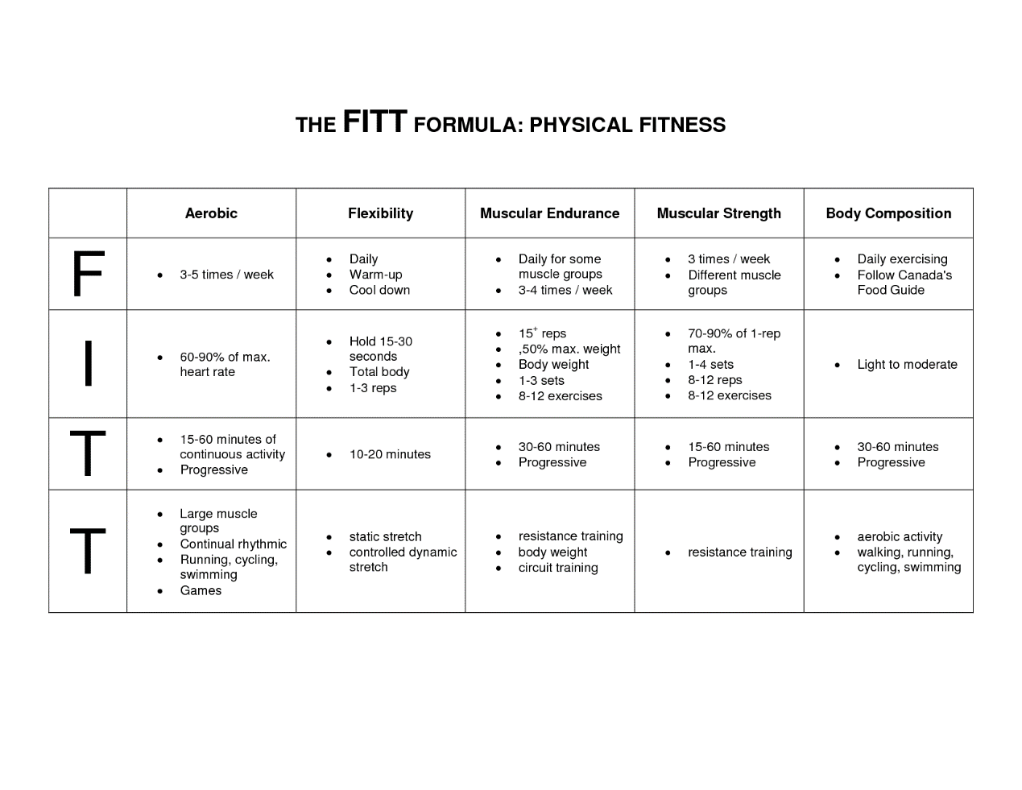](http://www.google.com/url?sa=i&rct=j&q=&esrc=s&source=images&cd=&cad=rja&uact=8&ved=0ahUKEwiyzcTu5sLKAhVEu4MKHdSKCQgQjRwIBw&url=http://fittprinciples.blogspot.com/&psig=AFQjCNHqa7gB7evrM5-M3lId55STd3VFtw&ust=1453736990724448)

[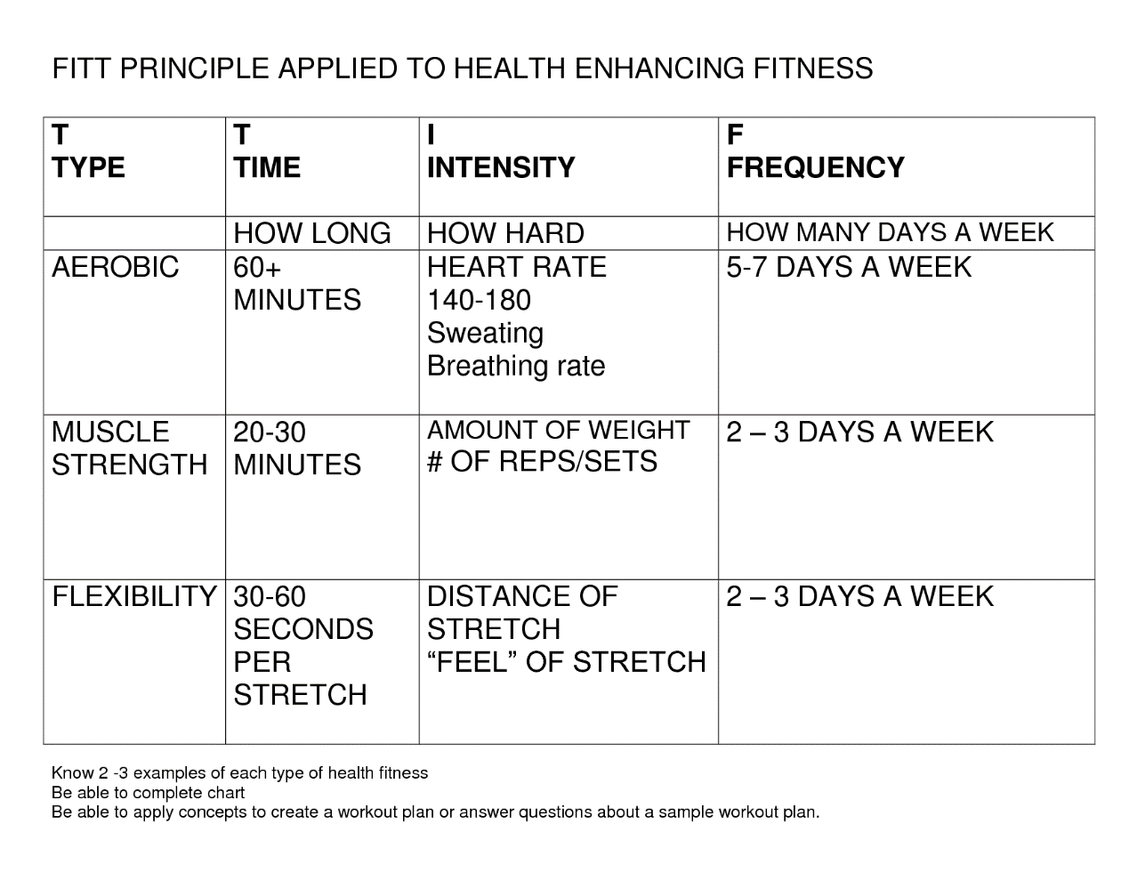](http://www.google.com/url?sa=i&rct=j&q=&esrc=s&source=images&cd=&cad=rja&uact=8&ved=0ahUKEwjkjpCR58LKAhWGvoMKHRyoCF8QjRwIBw&url=http://amandamcmenomy.blogspot.com/2013/07/my-weekly-exercise-program.html&psig=AFQjCNHqa7gB7evrM5-M3lId55STd3VFtw&ust=1453736990724448)

[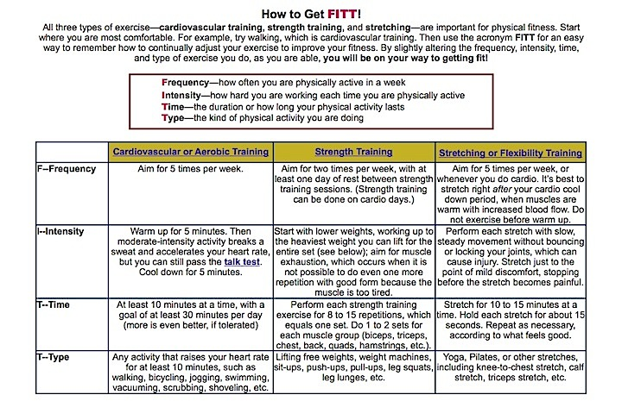](http://www.google.com/url?sa=i&rct=j&q=&esrc=s&source=images&cd=&cad=rja&uact=8&ved=0ahUKEwja47v558LKAhVCsoMKHe3LDnUQjRwIBw&url=http://www.secondscount.org/heart-condition-centers/info-detail-2/how-to-get-fitt&psig=AFQjCNHqa7gB7evrM5-M3lId55STd3VFtw&ust=1453736990724448)

[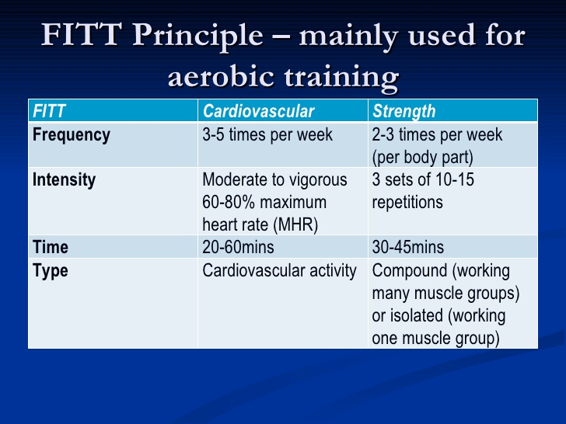](http://www.google.com/url?sa=i&rct=j&q=&esrc=s&source=images&cd=&cad=rja&uact=8&ved=0ahUKEwiWhunf58LKAhUpv4MKHTOLBcEQjRwIBw&url=http://www.slideshare.net/THACHR15/aerobic-and-anearobic-training&psig=AFQjCNHqa7gB7evrM5-M3lId55STd3VFtw&ust=1453736990724448)[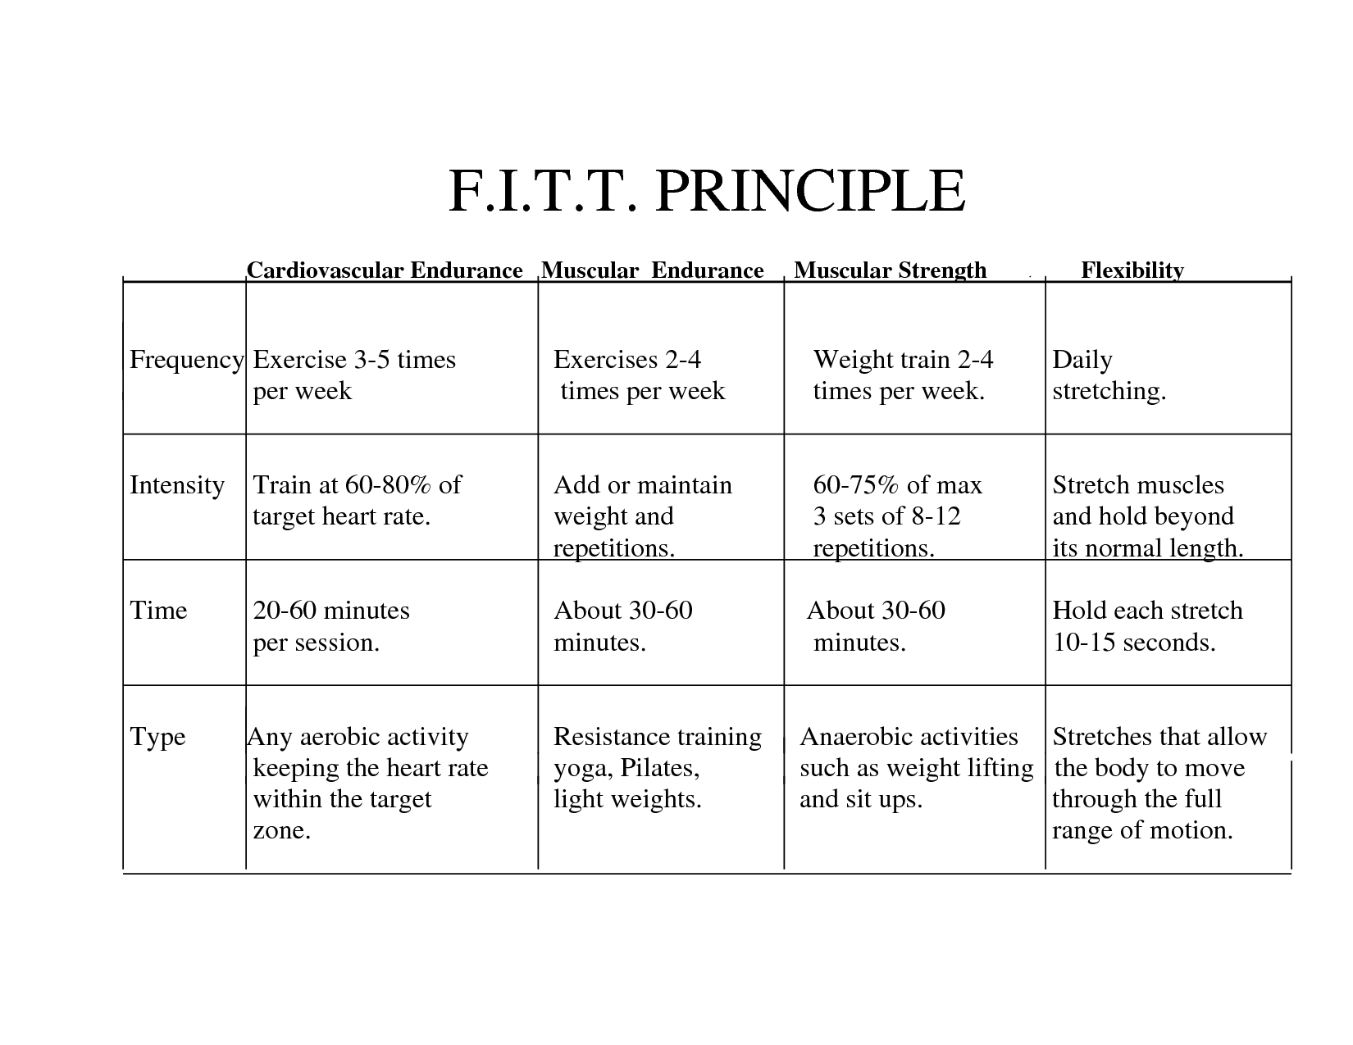](http://www.google.com/url?sa=i&rct=j&q=&esrc=s&source=images&cd=&cad=rja&uact=8&ved=0ahUKEwjkjpCR58LKAhWGvoMKHRyoCF8QjRwIBw&url=http://hawkspe.weebly.com/fitt-principle-of-exercise.html&psig=AFQjCNHqa7gB7evrM5-M3lId55STd3VFtw&ust=1453736990724448)

[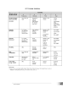](https://www.google.com/imgres?imgurl=http://image.slidesharecdn.com/moduleinst1-140913210636-phpapp02/95/module-in-st-1-distance-learning-17-638.jpg?cb=1410642523&imgrefurl=http://www.slideshare.net/remboltorio1/module-in-st-1-distance-learning&docid=1BWzyuDZwOpG7M&tbnid=Es_slKYI3ZiEyM:&w=638&h=826&ved=0ahUKEwjfpI-N58LKAhWrkYMKHSIYAGYQxiAICDAG&iact=c&ictx=1)